Valuing Australian landscapes –

Research task

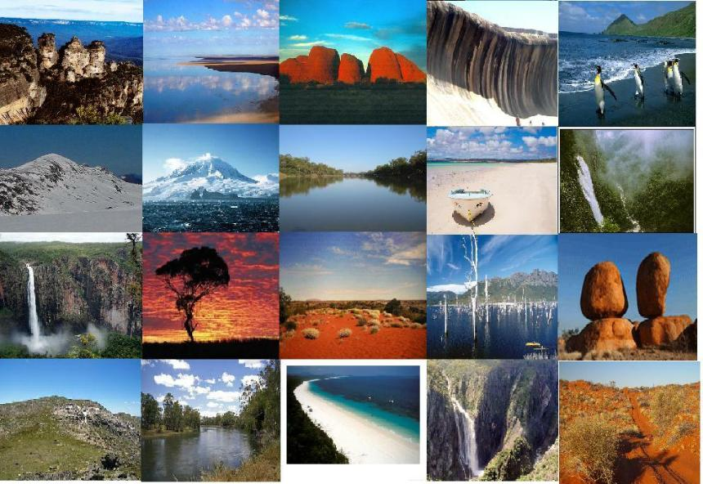

Year 8 Geography

Valuing landscapes – Research task

Complete the following activities for one of the iconic Australian landforms listed below.

|  |  |  |  |
| --- | --- | --- | --- |
| **Australian Landforms** | | | |
| *Blue lake, Mt Gambia*  *Devils marbles*  *Coorong peninsula*  *Glasshouse mountains* | *Great Barrier Reef*  *Jenolan caves*  *Jim Jim falls*  *Kata Tjuta* | *Lake Eyre*  *Mt Kosciuszko*  *Nullarbor Plain*  *The pinnacles* | *Three sisters*  *Twelve Apostles*  *Uluru*  *Wave Rock* |

***\*Make sure you answer all questions in full sentences.***

1. Which landform have you chosen to study and what type of landform is it?
2. Give the absolute location of the landform and also describe its relative location in Australia.
3. Write a paragraph to explain how the landform was formed. Use diagrams if you wish.
4. Name one example of the same landform in another part of the world and give the absolute location of this landform.
5. Mark the location of both landforms on the world map provided.
6. Write a paragraph to describe the landscape where the landforms are located. Make sure you comment on any obvious similarities and/or differences between the two locations.
7. Copy and complete the following table for each landform. Describe the aesthetic, emotional, spiritual and/or economic value of each and to whom.

|  |  |  |  |  |
| --- | --- | --- | --- | --- |
| **Landform** | **Aesthetic value** | **Emotional value** | **Spiritual value** | **Economic value** |
| **Australian example** |  |  |  |  |
| **World example** |  |  |  |  |

**Assessment criteria**

|  |  |  |
| --- | --- | --- |
|  | Possible grade | Grade |
| The landform and its location within Australia, has been identified. | 3 |  |
| A second example of the same landform and its location has been identified. | 3 |  |
| A detailed description of the processes forming the landform has been provided. | 5 |  |
| The landscapes have been accurately described including key elements of the landscape | 5 |  |
| The value of the landform/landscapes and key stakeholders have been identified | 5 |  |
| The map is neatly presented and includes geographic conventions - BOLTSS. | 3 |  |
| At least 3 sources have been correctly referenced in the Bibliography | 3 |  |
| Well-constructed sentences and correct spelling and grammar is used in descriptions. | 3 |  |
| **TOTAL** | 30 |  |

